MODULE III

Packet Switching-Switching and Forwarding- Datagram, virtual circuit switching, Source routing Bridges and LAN Switches-Learning Bridges, Spanning tree Algorithms ,Broadcast and Multicast, Limitations of bridges, Simple Internetworking-Service Model, Global Address, Datagram Forwarding in IP, address translation, Routing-network as graph, distance vector, link state, matrix

INTRODUCTION
The directly connected networks suffer from two limitations. First, there is a limit to how many hosts can be attached. Second, there is a limit to how large of a geographic area a single network can serve. Since our goal is to build networks that can be global in scale, the next problem is therefore to enable communication between hosts that are not directly connected. Computer networks use packet switches to enable packets to travel from one host to another, even when no direct connection exists between those hosts.
A packet switch is a device with several inputs and outputs leading to and from the hosts that the switch interconnects. The core job of a switch is to take packets that arrive on an input and forward (or switch) them to the right output so that they will reach their appropriate destination. There are a variety of ways that the switch can determine the “right” output for a packet, which can be broadly categorized as connectionless and connection-oriented approaches. A key problem that a switch must deal with is the finite bandwidth of its outputs. If packets destined for a certain output arrive at a switch and their arrival rate exceeds the capacity of that output, then there arises a problem of contention. The switch queues (buffers) packets until the contention subsides, but if it lasts too long, the switch will run out of buffer space and be forced to discard packets. When packets are discarded too frequently, the switch is said to be congested. The ability of a switch to handle contention is a key aspect of its performance.
SWITCHING AND FORWARDING
Switch
- A mechanism that allows us to interconnect links to form a large network
- A multi-input, multi-output device which transfers packets from an input to one or more outputs
- Adds the star topology to the point-to-point link, bus (Ethernet), and ring (802.5 and FDDI) topologies
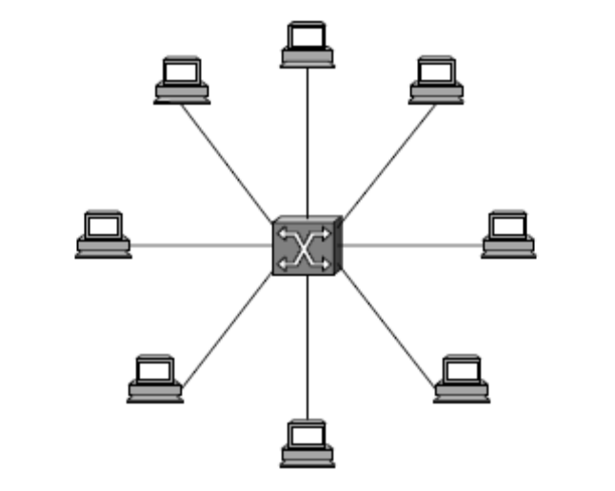
Fig: A switch provides a star topology
Properties of this star topology
- Even though a switch has a fixed number of inputs and outputs, which limits the number of hosts that can be connected to a single switch, large networks can be built by interconnecting a number of switches
- We can connect switches to each other and to hosts using point-to-point links, which typically means that we can build networks of large geographic scope
- Adding a new host to the network by connecting it to a switch does not necessarily mean that the hosts already connected will get worse performance from the network
A switch is connected to a set of links and for each of these links, runs the appropriate data link protocol to communicate with that node. A switch’s primary job is to receive incoming packets on one of its links and to transmit them on some other link. This function is referred as switching and forwarding. According to OSI architecture this is the main function of the network layer.
How does the switch decide which output port to place each packet on?
- It looks at the header of the packet for an identifier that it uses to make the decision
- Two common approaches
- Datagram or Connectionless approach
- Virtual circuit or Connection-oriented approach
- A third approach source routing is less common

DATAGRAMS
Key Idea
- Every packet contains enough information to enable any switch to decide how to get it to destination
  - Every packet contains the complete destination address
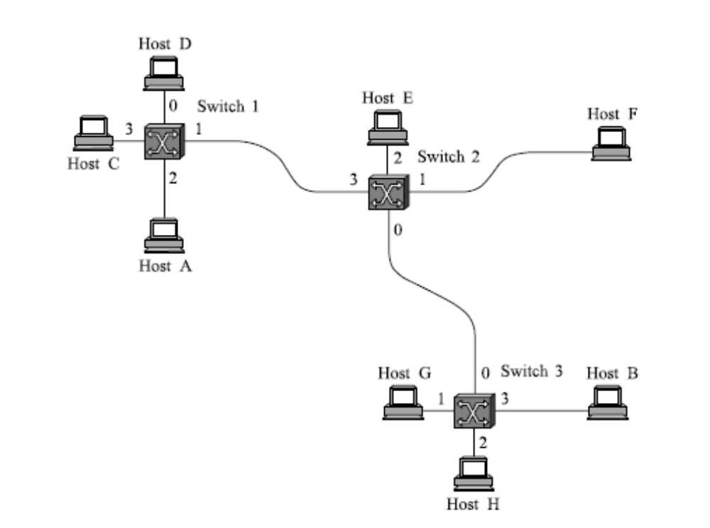
Fig: Datagram Forwarding
- To decide how to forward a packet, a switch consults a forwarding table (sometimes called a routing table
Connectionless (datagram) networks have the following characteristics:
- A host can send a packet anywhere at any time, since any packet that turns up at a switch can be immediately forwarded (assuming a correctly populated forwarding table).
- When a host sends a packet, it has no way of knowing if the network is capable of delivering it or if the destination host is even up and running.
- Each packet is forwarded independently of previous packets that might have been sent to the same destination. Thus two successive packets from host A to host B may follow completely different paths
- A switch or link failure might not have any serious effect on communication if it is possible to find an alternate route around the failure and update the forwarding table accordingly

VIRTUAL CIRCUIT SWITCHING
- Widely used technique for packet switching
- Uses the concept of virtual circuit (VC)
- Also called a connection-oriented model
- First set up a virtual connection from the source host to the destination host and then send the data
- Two-stage process
  - Connection setup
  - Data Transfer
- Connection setup
  - Establish “connection state” in each of the switches between the source and destination hosts
  - The connection state for a single connection consists of an entry in the “VC table” in each switch through which the connection passes
- One entry in the VC table on a single switch contains
  - A virtual circuit identifier (VCI) that uniquely identifies the connection at this switch and that will be carried inside the header of the packets that belong to this connection
  - An incoming interface on which packets for this VC arrive at the switch
  - An outgoing interface in which packets for this VC leave the switch
  - A potentially different VCI that will be used for outgoing packets
- The semantics(meaning) for one such entry is
  - If a packet arrives on the designated incoming interface and that packet contains the designated VCI value in its header, then the packet should be sent out the specified outgoing interface with the specified outgoing VCI value first having been placed in its header
- The combination of the VCI of the packets as they are received at the switch and the interface on which they are received uniquely identifies the virtual connection
- There may be many virtual connections established in the switch at one time
- Incoming and outgoing VCI values are not generally the same
- VCI is not a globally significant identifier for the connection; rather it has significance only on a given link
- Whenever a new connection is created, assign a new VCI for that connection on each link that the connection will traverse
- Ensure that the chosen VCI on a given link is not currently in use on that link by some existing connection.
Two broad classes of approach to establishing connection state
- Network Administrator will configure the state
  - The virtual circuit is permanent (PVC)
  - The network administrator can delete this
  - Can be thought of as a long-lived or administratively configured VC
- A host can send messages into the network to cause the state to be established
  - This is referred as signaling and the resulting virtual circuit is said to be switched (SVC)
  - A host may set up and delete such a VC dynamically without the involvement of a network administrator
- In real networks of reasonable size, the burden of configuring VC tables correctly in a large number of switches would quickly become excessive. Thus, some sort of signalling is almost always used, even when setting up “permanent” VCs. In case of PVCs, signaling is initiated by the network administrator. SVCs are usually set up using signalling by one of the hosts.
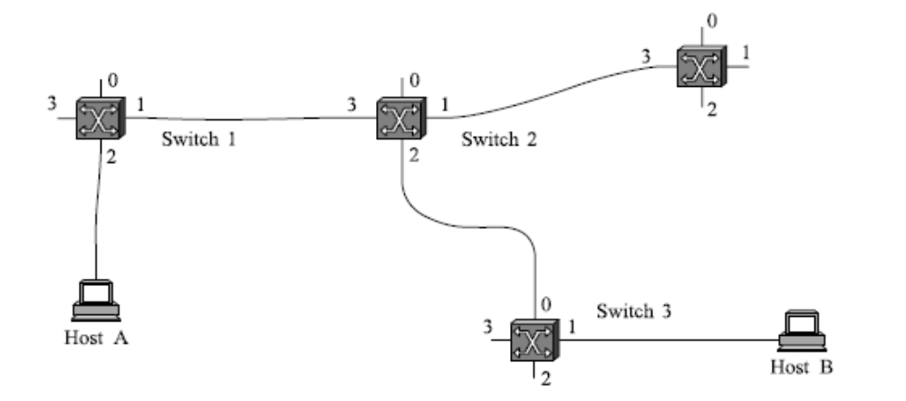
Fig: Example of a Virtual Circuit Network
- How does the signalling work
- To start the signalling process, host A sends a setup message into the network (i.e. to switch 1)
  - The setup message contains (among other things) the complete destination address of B.
  - The setup message needs to get all the way to B to create the necessary connection state in every switch along the way
  - It is like sending a datagram to B where every switch knows which output to send the setup message so that it eventually reaches B
  - Assume that every switch knows the topology to figure out how to do that
- When switch 1 receives the connection request, in addition to sending it on to switch 2, it creates a new entry in its VC table for this new connection
  - Switch 1 picks the value 5 for this connection
- When switch 2 receives the setup message, it performs the similar process and it picks the value 11 as the incoming VCI
- Similarly switch 3 picks 7 as the value for its incoming VCI
  - Each switch can pick any number it likes, as long as that number is not currently in use for some other connection on that port of that switch
- Finally the setup message arrives at host B.
- Assuming that B is healthy and willing to accept a connection from host A, it allocates an incoming VCI value, in this case 4.
  - This VCI value can be used by B to identify all packets coming from A
- Now to complete the connection, everyone needs to be told what their downstream neighbor is using as the VCI for this connection
  - Host B sends an acknowledgement of the connection setup to switch 3 and includes in that message the VCI value that it chose (4)
  - Switch 3 completes the VC table entry for this connection and sends the acknowledgement on to switch 2 specifying the VCI of 7
  - Switch 2 completes the VC table entry for this connection and sends acknowledgement on to switch 1 specifying the VCI of 11
  - Finally switch 1 passes the acknowledgement on to host A telling it to use the VCI value of 5 for this connection
- When host A no longer wants to send data to host B, it tears down the connection by sending a teardown message to switch 1
- The switch 1 removes the relevant entry from its table and forwards the message on to the other switches in the path which similarly delete the appropriate table entries
- At this point, if host A were to send a packet with a VCI of 5 to switch 1, it would be dropped as if the connection had never existed
Characteristics of VC
- Since host A has to wait for the connection request to reach the far side of the network and return before it can send its first data packet, there is at least one RTT of delay before data is sent
- While the connection request contains the full address for host B (which might be quite large, being a global identifier on the network), each data packet contains only a small identifier, which is only unique on one link.
  - Thus the per-packet overhead caused by the header is reduced relative to the datagram model
- If a switch or a link in a connection fails, the connection is broken and a new one will need to be established.
  - Also the old one needs to be torn down to free up table storage space in the switches
- The issue of how a switch decides which link to forward the connection request on has similarities with the function of a routing algorithm
Good Properties of Virtual Circuits
- By the time the host gets the go-ahead to send data, it knows quite a lot about the network
  - For example, that there is really a route to the receiver and that the receiver is willing to receive data
- It is also possible to allocate resources to the virtual circuit at the time it is established

SOURCE ROUTING
- All the information about network topology that is required to switch a packet across the network is provided by the source host
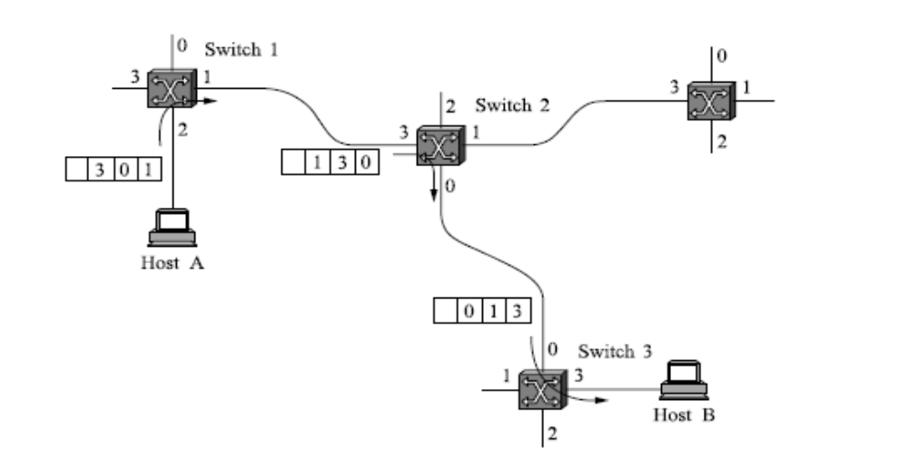
Fig: Source routing in a switched network
Other approaches in Source Routing
- Rotation- Each switch rotates the list after it has read its own entry
- Stripping- Each switch strips the first element as it uses it
- Using Pointers- the header carry a pointer to the current “next port” entry and each switch just updates the pointer
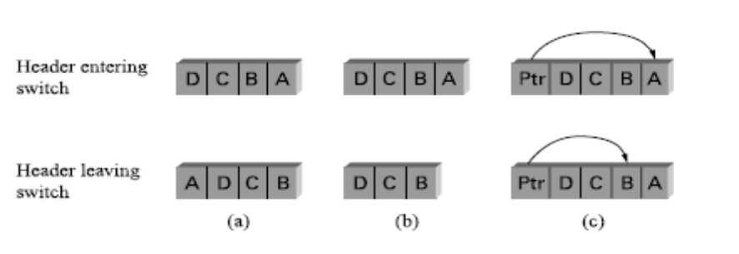
Fig: Three ways to handle headers for source routing a) Rotation b) Stripping c) Using Pointers

BRIDGES AND LAN SWITCHES
- Class of switches that is used to forward packets between shared-media LANs such as Ethernets
- Known as LAN switches
- Referred to as Bridges
- A collection of LANs connected by one or more bridges is usually said to form an Extended LAN

Simplest Strategy for Bridges
- Accept LAN frames on their inputs and forward them out to all other outputs
- Used by early bridges
- Observe that there is no need to forward all the frames that a bridge receives
SPANNING TREE ALGORITHM
A spanning tree is a sub-graph of this graph that covers all the vertices but contains no cycles. Spanning tree keeps all the vertices of the original graph but throws out some of the edges. If the extended LAN is represented by a graph that possibly has loops (cycles), then a spanning tree is a subgraph of this graph that covers (spans) all the vertices, but contains no cycles. That is, a spanning tree keeps all of the vertices of the original graph, but throws out some of the edges.
Developed by Radia Perlman at Digital
- A protocol used by a set of bridges to agree upon a spanning tree for a particular extended LAN
- Each bridge decides the ports over which it is and is not willing to forward frames
  - In a sense, it is by removing ports from the topology that the extended LAN is reduced to an acyclic tree
  - It is even possible that an entire bridge will not participate in forwarding frames
  - Algorithm is dynamic
    - The bridges are always prepared to reconfigure themselves into a new spanning tree if some bridges fail
Main idea of Spanning Tree Algorithm
- Each bridge selects the ports over which they will forward the frames
- Algorithm selects ports as follows:
  - Each bridge has a unique identifier
    - B1, B2, B3,…and so on.
  - Elect the bridge with the smallest id as the root of the spanning tree
  - The root bridge always forwards frames out over all of its ports
  - Each bridge computes the shortest path to the root and notes which of its ports is on this path
    - This port is selected as the bridge’s preferred path to the root
  - Finally, all the bridges connected to a given LAN elect a single designated bridge that will be responsible for forwarding frames toward the root bridge
- Each LAN’s designated bridge is the one that is closest to the root
  - If two or more bridges are equally close to the root,
    - Then select bridge with the smallest id
- Each bridge is connected to more than one LAN
  - So it participates in the election of a designated bridge for each LAN it is connected to.
  - Each bridge decides if it is the designated bridge relative to each of its ports
  - The bridge forwards frames over those ports for which it is the designated bridge
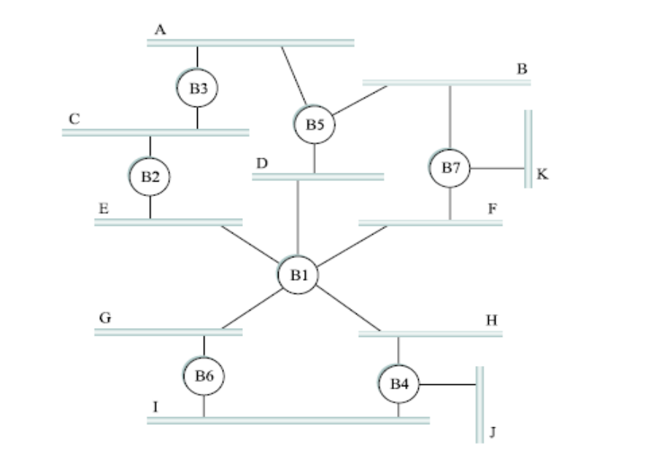

Fig: Extended LAN with loops
In this figure, B1 is the root bridge, since it has the smallest ID. Both B3 and B5 are connected to LAN A, but B5 is the designated bridge since it is closer to the root. Similarly, both B5 and B7 are connected to LAN B, but in this case, B5 is the designated bridge since it has the smaller ID; both are an equal distance from B1.
The bridges have to exchange configuration messages with each other and then decide whether or not they are the root or a designated bridge based on these messages. The configuration messages contain three pieces of information:
- The ID for the bridge that is sending the message;
- The ID for what the sending bridge believes to be the root bridge;
- The distance, measured in hops, from the sending bridge to the root bridge
Initially each bridge thinks it is the root, so it sends a configuration message on each of its ports identifying itself as the root and giving a distance to the root of 0. Upon receiving a configuration message over a particular port, the bridge checks to see if the new message is better than the current best configuration message recorded for that port. The new configuration is better than the currently recorded information if
- It identifies a root with a smaller id or
- It identifies a root with an equal id but with a shorter distance or
- The root id and distance are equal, but the sending bridge has a smaller id
If the new message is better than the currently recorded one,
- The bridge discards the old information and saves the new information
- It first adds 1 to the distance-to-root field
When a bridge receives a configuration message indicating that it is not the root bridge (that is, a message from a bridge with smaller id)
- The bridge stops generating configuration messages on its own
- Only forwards configuration messages from other bridges after adding one to the distance field
When a bridge receives a configuration message that indicates it is not the designated bridge for that port (a message from a bridge that is closer to the root or equally far from the root but with a smaller id)
- The bridge stops sending configuration messages over that port
When the system stabilizes,
- Only the root bridge is still generating configuration messages.
- Other bridges are forwarding these messages only over ports for which they are the designated bridge
For example, consider the activity at node B3 (consider the above figure)
B3 receives (B2, 0, B2). Since 2 < 3, B3 accepts B2 as root. B3 adds 1 to the distance advertised by B2 and sends (B2, 1, B3) to B5. Meanwhile B2 accepts B1 as root because it has the lower id and it sends (B1, 1, B2) toward B3. B5 accepts B1 as root and sends (B1, 1, B5) to B3. B3 accepts B1 as root and it notes that both B2 and B5 are closer to the root than it is. Thus B3 stops forwarding messages on both its interfaces. This leaves B3 with both ports not selected.
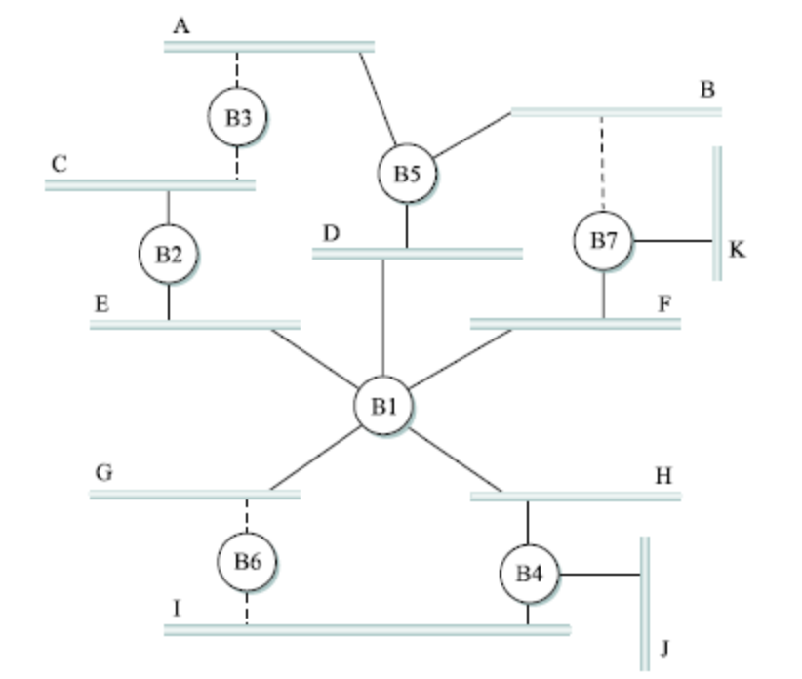
Fig: Spanning Tree with some ports not selected
- Even after the system has stabilized, the root bridge continues to send configuration messages periodically
  - Other bridges continue to forward these messages
- When a bridge fails, the downstream bridges will not receive the configuration messages. After waiting a specified period of time, they will once again claim to be the root and the algorithm starts again.
- Although the algorithm is able to reconfigure the spanning tree whenever a bridge fails, it is not able to forward frames over alternative paths for the sake of routing around a congested bridge

BROADCAST AND MULTICAST
Broadcast-Each bridge forwards a frame with a destination broadcast address out on each active (selected) port other than the one on which the frame was received.
Mulicast
- Can be accomplished in the same way as that of broadcast or
- Each member of the multicast group G send a frame to bridge’s multicast address with the address for group G in source field of the frame

LIMITATIONS OF BRIDGES
- Bridges do not scale
  - Spanning tree algorithm does not scale
  - Broadcast does not scale
As a consequence extended LANs do not scale.
- Bridges do not accommodate heterogeneity
  - Bridges are limited in the kinds of networks they can interconnect
    - Support only networks that have exactly the same format for addresses
Virtual LANS(VLANs)
One approach to increasing the scalability of extended LANs is the virtual LAN (VLAN). VLANs allow a single extended LAN to be partitioned into several seemingly separate LANs. Each virtual LAN is assigned an identifier (sometimes called a color), and packets can only travel from one segment to another if both segments have the same identifier. This has the effect of limiting the number of segments in an extended LAN that will receive any given broadcast packet.
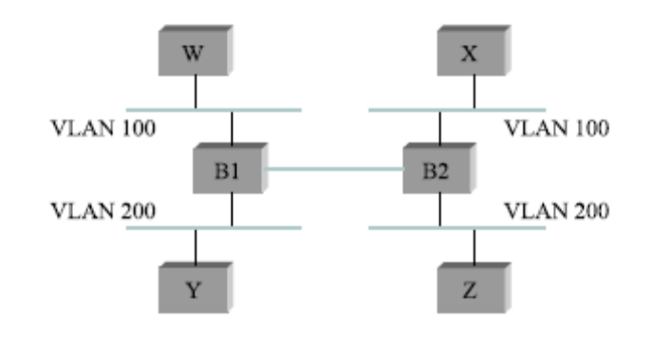
Fig: Two virtual LANs share a common backbone

INTERNETWORKING
Internetwork: An arbitrary collection of networks interconnected to provide some sort of host-to host packet delivery service. An internetwork is often referred to as a network of networks because it is made up of lots of smaller networks.
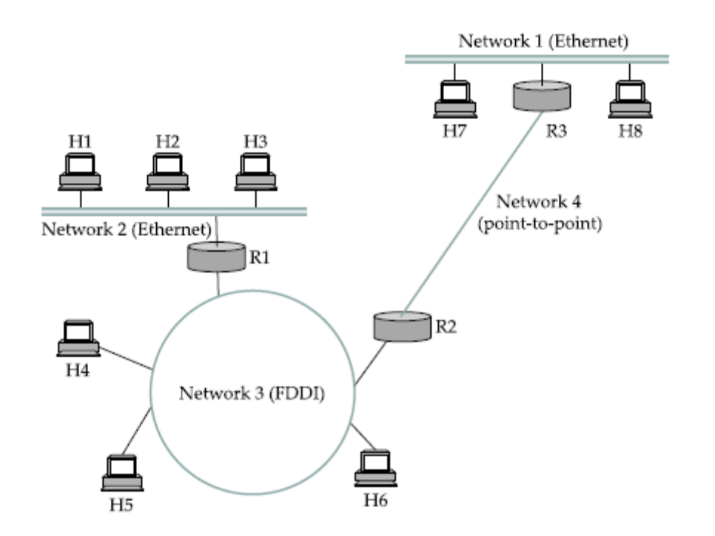
Fig: An internetwork H_{n}: Host, R_{n}: Routers
The Internet Protocol is the key tool used today to build scalable, heterogeneous internetworks. It was originally known as the Kahn-Cerf protocol after its inventors. IP runs on all the nodes (both hosts and routers) in a collection of networks and defines the infrastructure that allows these nodes and networks to function as a single logical internetwork.

SERVICE MODEL
The IP service model has two parts: an addressing scheme, which provides a way to identify all hosts in the internetwork, and a datagram (connectionless) model of data delivery. This service model is sometimes called best effort because, although IP makes every effort to deliver datagrams, it makes no guarantees.
Datagram Delivery
A datagram is a type of packet that happens to be sent in a connectionless manner over a network. Every datagram carries enough information to let the network forward the packet to its correct destination.

IP Packet Format
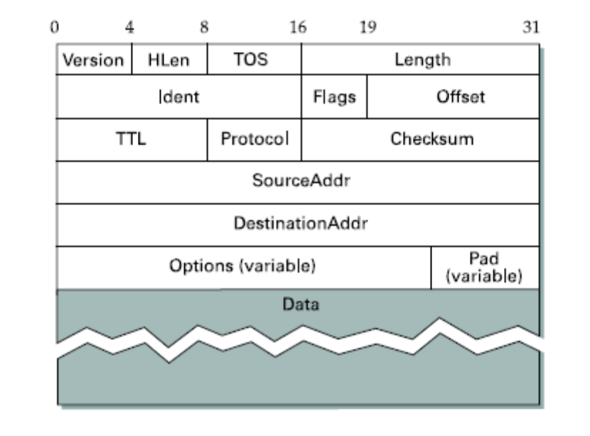
Fig: IPV4 Packet Header
IP Packet Header Fields
- Version number (4 bits)
  - Indicates the version of the IP protocol
  - Necessary to know what other fields to expect
  - Typically “4” (for IPv4), and sometimes “6” (for IPv6)
- HLen- Header length (4 bits)
  - Number of 32-bit words in the header
  - Typically “5” (for a 20-byte IPv4 header)
  - Can be more when “IP options” are used
- TOS- Type-of-Service (8 bits)
  - Allow packets to be treated differently based on needs
  - E.g., low delay for audio, high bandwidth for bulk transfer
- Length (16 bits)
  - Number of bytes in the packet
  - Maximum size is 63,535 bytes (2^16 -1)
  - … though underlying links may impose harder limits
- Fragmentation information (32 bits)
  - Packet identifier, flags, and fragment offset
  - Supports dividing a large IP packet into fragments
  - … in case a link cannot handle a large IP packet
- Time-To-Live (8 bits)
  - Used to identify packets stuck in forwarding loops
  - … and eventually discard them from the network
  - TTL field decremented by each router on the path
  - Packet is discarded when TTL field reaches and “time exceeded” message is sent to the source
- Protocol (8 bits)
  - Identifies the higher-level protocol
  - E.g., “6” for the Transmission Control Protocol (TCP)
  - E.g., “17” for the User Datagram Protocol (UDP)
  - Important for demultiplexing at receiving host
  - Indicates what kind of header to expect next
- Checksum (16 bits)
  - Sum of all 16-bit words in the IP packet header
  - If any bits of the header are corrupted in transit
  - … the checksum won’t match at receiving host
  - Receiving host discards corrupted packets
    - Sending host will retransmit the packet, if needed
- Two IP addresses
  - Source IP address (32 bits)
  - Destination IP address (32 bits)
- Destination address
  - Unique identifier for the receiving host
  - Every packet contains a full address for its intended destination so that forwarding decisions can be made at each router
  - Allows each node to make forwarding decisions
- Source address
  - Unique identifier for the sending host
  - Recipient can decide whether to accept packet
  - Enables recipient to send a reply back to source

IP Fragmentation and Reassembly
- Each network has some MTU (Maximum Transmission Unit) which is the largest IP datagram that it can carry in a frame. For example, Ethernet (1500 bytes), FDDI (4500 bytes)
- Strategy
  - Fragmentation occurs in a router when it receives a datagram that it wants to forward over a network which has (MTU < datagram)
  - Reassembly is done at the receiving host, not at the router
  - All the fragments carry the same identifier in the Ident field. This identifier is chosen by the sending host and is intended to be unique among all that datagrams that might arrive at the destination from this source over some reasonable time period
  - Fragments are self-contained datagrams
  - IP does not recover from missing fragments
GLOBAL ADDRESSES (IP ADDRESSES)
An IPv4 address is a 32-bit address that uniquely and universally defines the connection of a device (for example, a computer or a router) to the Internet. IPv4 addresses are unique. They are unique in the sense that each address defines one, and only one, connection to the Internet. Two devices on the Internet can never have the same address at the same time. An address may be assigned to a device for a time period and then taken away and assigned to another device.
Address Space
A protocol such as IPv4 that defines addresses has an address space. An address space is the total number of addresses used by the protocol. If a protocol uses N bits to define an address, the address space is 2^N because each bit can have two different values (0 or 1) and N bits can have 2N values. IPv4 uses 32-bit addresses, which means that the address space is 232 or 4,294,967,296 (more than 4 billion). This means that, more than 4 billion devices could be connected to the Internet.
Notations
There are two prevalent notations to show an IPv4 address: binary notation and dotted decimal notation.
Binary Notation
In binary notation, the IPv4 address is displayed as 32 bits. Each octet is often referred to as a byte. So it is common to hear an IPv4 address referred to as a 32-bit address or a 4-byte address. The following is an example of an IPv4 address in binary notation:
01110101 10010101 00011101 00000010
Dotted-Decimal Notation
To make the IPv4 address more compact and easier to read, Internet addresses are usually written in decimal form with a decimal point (dot) separating the bytes. The following is the dotted-decimal notation of the above address:
117.149.29.2
Note that because each byte (octet) is 8 bits, each number in dotted-decimal notation is a value ranging from 0 to 255T
The address space is divided into five classes: A, B, C, D, and E. Each class occupies some part of the address space. An IP address in class A, B, or C is divided into netid and hostid. These parts are of varying lengths, depending on the class of the address

 | First Byte | Second Byte | Third Byte | Fourth Byte
Class A | 0
Class B | 10
Class C | 110
Class D | 1110
Class E | 1111
Binary Notation

 | First Byte | Second Byte | Third Byte | Fourth Byte
Class A | 0-127
Class B | 128-191
Class C | 192-223
Class D | 224-239
Class E | 240-255
Dotted-Decimal Notation

Network ID
Host ID

IP DATAGRAM FORWARDING
- Strategy
  - Every IP datagram contains the IP address of the destination host
  - If the host or router is directly connected to destination network, then forward the datagram to destination host
  - If not directly connected to destination network, then forward to some router. The router finds the correct next hop by consulting its forwarding table.
  - Forwarding table maps network number into next hop
  - Each host has a default router; each router maintains a forwarding table
- Datagram Forwarding Algorithm
if (NetworkNum of destination = NetworkNum of one of my interfaces) then
deliver packet to destination over that interface
else
if (NetworkNum of destination is in my forwarding table) then
deliver packet to NextHop router
else
deliver packet to default router
For a host with only one interface and only a default router in its forwarding table, this simplifies to
if (NetworkNum of destination = my NetworkNum) then
deliver packet to destination directly
else
deliver packet to default router

ADDRESS TRANSLATION
An internet is made of a combination of physical networks connected by internetworking devices such as routers. A packet starting from a source host may pass through several different physical networks before finally reaching the destination host. The hosts and routers are recognized at the network level by their logical (IP) addresses. However, packets pass through physical networks to reach these hosts and routers. At the physical level, the hosts and routers are recognized by their physical addresses. A physical address is a local address. Its jurisdiction is a local network. It must be unique locally, but is not necessarily unique universally. It is called a physical address because it is usually (but not always) implemented in hardware. An example of a physical address is the 48-bit MAC address in the Ethernet protocol, which is imprinted on the NIC installed in the host or router.
Delivery of a packet to a host or a router requires two levels of addressing: logical and physical. So it is required to map a logical address to its corresponding physical address and vice versa. These can be done by using either static or dynamic mapping.
Static mapping involves in the creation of a table that associates a logical address with a physical address. This table is stored in each machine on the network. Each machine that knows, for example, the IP address of another machine but not its physical address can look it up in the table.
In dynamic mapping each time a machine knows one of the two addresses (logical or physical), it can use a protocol to find the other one.
Mapping Logical to Physical Address: ARP
Anytime a host or a router has an IP datagram to send to another host or router, it has the logical (IP) address of the receiver. But the IP datagram must be encapsulated in a frame to be able to pass through the physical network. This means that the sender needs the physical address of the receiver. The host or the router sends an ARP query packet. The packet includes the physical and IP addresses of the sender and the IP address of the receiver. Because the sender does not know the physical address of the receiver, the query is broadcast over the network. Every host or router on the network receives and processes the ARP query packet, but only the intended recipient recognizes its IP address and sends back an ARP response packet. The response packet contains the recipient's IP and physical addresses. The packet is unicast directly to the inquirer by using the physical address received in the query packet.
ARP Packet Format
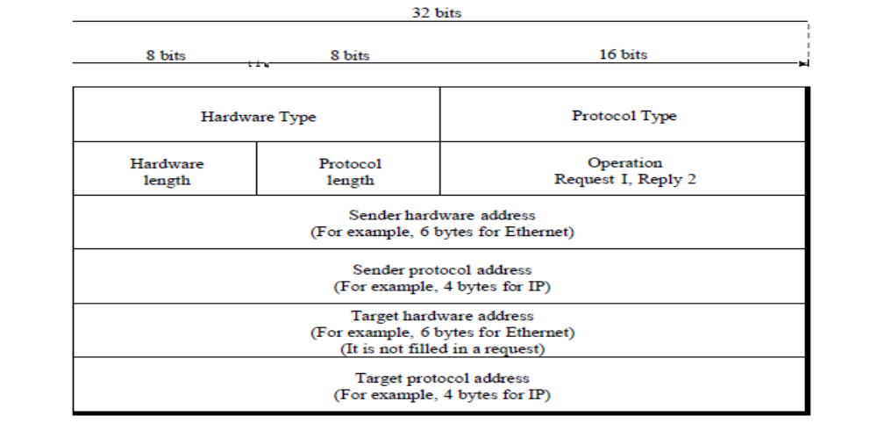
The fields are as follows:
- Hardware type. This is a 16-bit field defining the type of the network on which ARP is running. Each LAN has been assigned an integer based on its type. For example, Ethernet is given type 1. ARP can be used on any physical network.
- Protocol type. This is a 16-bit field defining the protocol. For example, the value of this field for the IPv4 protocol is 080016, ARP can be used with any higher-level protocol.
- Hardware length. This is an 8-bit field defining the length of the physical address in bytes. For example, for Ethernet the value is 6.
- Protocol length. This is an 8-bit field defining the length of the logical address in bytes. For example, for the IPv4 protocol the value is 4.
- Operation. This is a 16-bit field defining the type of packet. Two packet types are defined: ARP request (1) and ARP reply (2).
- Sender hardware address. This is a variable-length field defining the physical address of the sender. For example, for Ethernet this field is 6 bytes long.
- Sender protocol address. This is a variable-length field defining the logical (for example, IP) address of the sender. For the IP protocol, this field is 4 bytes long.
- Target hardware address. This is a variable-length field defining the physical address of the target. For example, for Ethernet this field is 6 bytes long. For an ARP request message, this field is alIOs because the sender does not know the physical address of the target.
- Target protocol address. This is a variable-length field defining the logical (for example, IP) address of the target. For the IPv4 protocol, this field is 4 bytes long.
ROUTING
Forwarding consists of taking a packet, looking at its destination address, consulting a table, and sending the packet in a direction determined by that table. Routing is the process by which forwarding tables are built. The forwarding table is used when a packet is being forwarded and so must contain enough information to accomplish the forwarding function. This means that a row in the forwarding table contains the mapping from a network number to an outgoing interface and some MAC information, such as the Ethernet address of the next hop. The routing table, on the other hand, is the table that is built up by the routing algorithms as a precursor to building the forwarding table.
It generally contains mappings from network numbers to next hops. It may also contain information about how this information was learned, so that the router will be able to decide when it should discard some information.
NETWORK AS A GRAPH
Routing is, a problem of graph theory. Figure 4.13 shows a graph representing a network. The nodes of the graph, labeled A through F, may be hosts, switches, routers, or networks. The edges of the graph correspond to the network links. Each edge has an associated cost, which gives some indication of the desirability of sending traffic over that link.
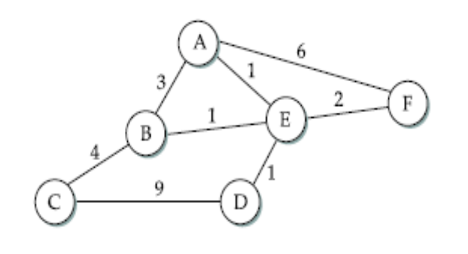
Fig: Network represented as graph
The basic problem of routing is to find the lowest-cost path between any two nodes, where the cost of a path equals the sum of the costs of all the edges that make up the path. For a simple network, calculate all shortest paths and load them into some nonvolatile storage on each node. Such a static approach has several shortcomings
    - It does not deal with node or link failures
    - It does not consider the addition of new nodes or links
    - It implies that edge costs cannot change
What is the solution?
    - Need a distributed and dynamic protocol
    - Two main classes of protocols
      - Distance Vector
      - Link State

DISTANCE VECTOR
Each node constructs a one-dimensional array (a vector) containing the “distances” (costs) to all other nodes and distributes that vector to its immediate neighbors. The starting assumption for distance-vector routing is that each node knows the cost of the link to each of its directly connected neighbors. A link that is down is assigned an infinite cost.

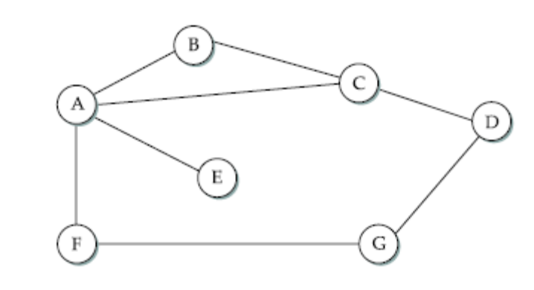
Fig: Distance Vector Routing, an example network
In the above figure, the cost of each link is set to 1, so that a least-cost path is simply the one with the fewest hops.
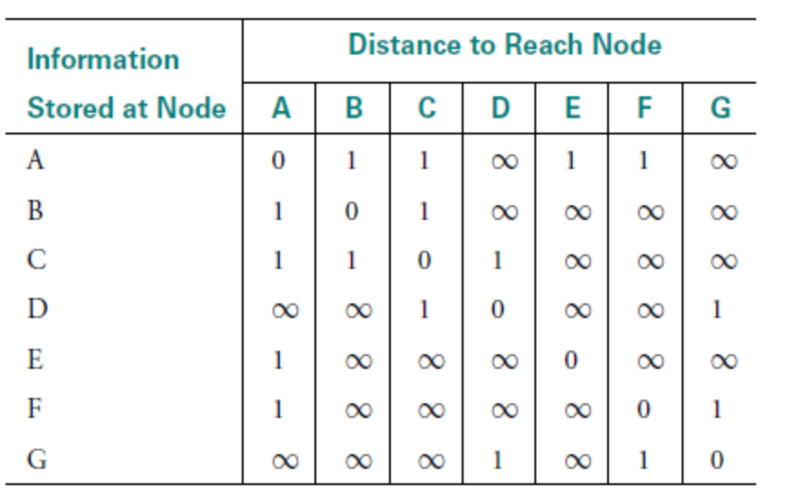
Fig: Initial Distances stored at each node
Consider each row in the table as a list of distances from one node to all other nodes, representing the current beliefs of that node. Initially, each node sets a cost of 1 to its directly connected neighbors and ∞ to all other nodes. Thus, A initially believes that it can reach B in one hop and that D is unreachable
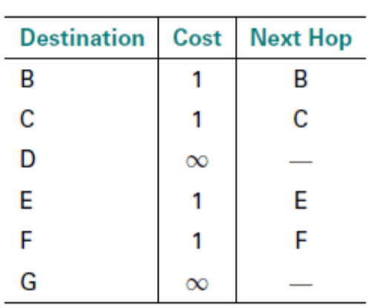
Fig: Initial routing table at node A
The next step in distance-vector routing is that every node sends a message to its directly connected neighbors containing its personal list of distances.
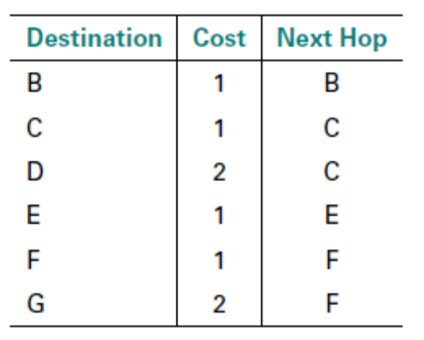
Fig: Final routing table at node A
After the exchange of information A can update its routing table with costs and next hops for all nodes in the network as in the above figure. In the absence of any topology changes, it only takes a few exchanges of information between neighbors before each node has a complete routing table. The process of getting consistent routing information to all the nodes is called convergence. The following table shows the final set of costs from each node to all other nodes when routing has converged.
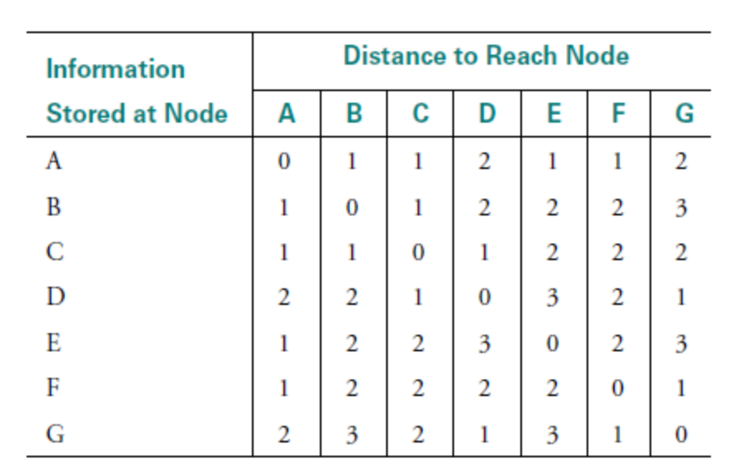
Fig: Final distances stored at each node
There are two different circumstances under which a given node decides to send a routing update to its neighbors.
- Periodic Update
  - Each node automatically sends an update message every so often, even if nothing has changed
- Triggered Update
  - Happens whenever a node receives an update from one of its neighbors that causes it to change one of the routes in its routing table
When a node detects a link failure, the nodes that notice first send new lists of distances to their neighbors, and normally the system settles down fairly quickly to a new state.
For example, F detects that link to G has failed
F sets distance to G to infinity and sends update to A. A sets distance to G to infinity since it uses F to reach G. When A receives periodic update from C with 2-hop path to G, A sets distance to G to 3 and sends update to F. F decides it can reach G in 4 hops via A and the system would again become stable.
- The distance vector routing algorithm is sometimes called as Bellman-Ford algorithm
- Every T seconds each router sends its table to its neighbor each router then updates its table based on the new information
- Problems include fast response to good news and slow response to bad news.

Count to Infinity Problem
A problem with distance vector routing is instability, which means that a network using this protocol can become unstable. Suppose the link from A to E goes down (see the above figure)
In the next round of updates, A advertises a distance of infinity to E, but B and C advertise a distance of 2 to E. Depending on the exact timing of events, the following might happen Node B, upon hearing that E can be reached in 2 hops from C, concludes that it can reach E in 3 hops and advertises this to A. Node A concludes that it can reach E in 4 hops and advertises this to C. Node C concludes that it can reach E in 5 hops; and so on. This cycle stops only when the distances reach some number that is large enough to be considered infinite.
Solutions to solve the Problem
- Defining Infinity- Redefine infinity to a smaller number
- Split Horizon- When a node sends a routing update to its neighbors, it does not send those routes it learned from each neighbor back to that neighbor
- Split Horizon with Poison Reverse- When a node sends a routing update to its neighbors; it does send those routes it learned from each neighbor back to that neighbor but with negative information.

LINK STATE ROUTING
Strategy: Send to all nodes (not just neighbors) information about directly connected links (not entire routing table).
The basic idea behind link-state protocols is: Every node knows how to reach its directly connected neighbors, and if this knowledge is disseminated to every node, then every node will have enough knowledge of the network to build a complete map of the network. This is clearly a sufficient condition for finding the shortest path to any point in the network. Thus, link-state routing protocols rely on two mechanisms: reliable dissemination of link-state information, and the calculation of routes from the sum of all the accumulated link-state knowledge.
Each node creates an update packet, also called a link-state packet (LSP) that contains the following information:
- The ID of the node that created the LSP;
- A list of directly connected neighbors of that node, with the cost of the link to each one;
- A sequence number: To make sure that old information is replaced by newer information, LSPs carry sequence numbers. Each time a node generates a new LSP, it increments the sequence number by 1
- A time to live for this packet: Used to ensure that old link-state information is eventually removed from the network. A node always decrements the TTL of a newly received LSP before flooding it to its neighbors.
Reliable Flooding
Reliable flooding is the process of making sure that all the nodes participating in the routing protocol get a copy of the link-state information from all the other nodes.
- A node store most recent LSP from each node
- Forward LSP to all nodes but one that sent it
- Generate new LSP periodically; increment SEQNO
- Start SEQNO at 0 when reboot
- Decrement TTL of each stored LSP; discard when TTL=0
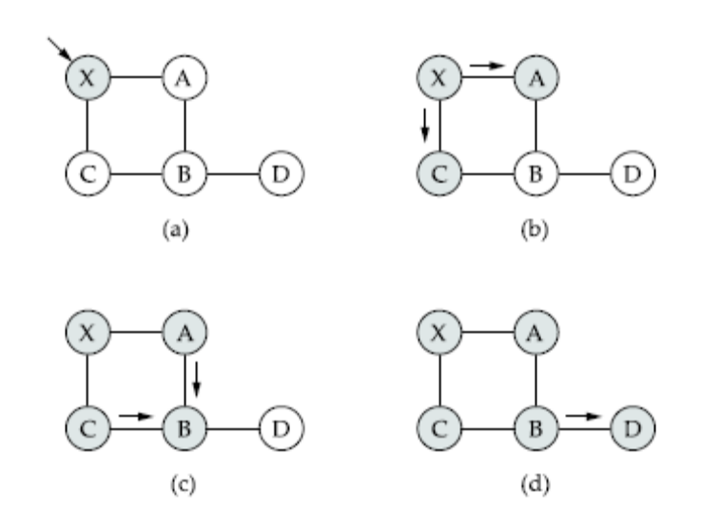
Fig: Flooding of link-state packets: (a) LSP arrives at node X; (b) X floods LSP
to A and C; (c ) A and C flood LSP to B (but not X); (d) flooding is complete
Route Calculation
Once a given node has a copy of the LSP from every other node, it is able to compute a complete map for the topology of the network, and from this map it is able to decide the best route to each destination. For this uses the Dijkstra’s Shortest Path Algorithm.
- Assume non-negative link weights
- N: set of nodes in the graph

- l((i, j): the non-negative cost associated with the edge between nodes i, j ∈N and l(i, j) = ∝ if no edge connects i and j
- Let s ∈N be the starting node which executes the algorithm to find shortest paths to all other nodes in N
- Two variables used by the algorithm
  - M: set of nodes incorporated so far by the algorithm
  - C(n) : the cost of the path from s to each node n
Algorithm
M = {s}
For each n in N – {s}
C(n) = l(s, n)
while ( N ≠ M)
M = M ∪ {w} such that C(w) is the minimum for all w in (N-M)
For each n in (N-M)
C(n) = MIN (C(n), C(w) + l(w, n))
Each switch computes its routing table directly from the LSPs it has collected using a realization of Dijkstra’s algorithm called the forward search algorithm. Each switch maintains two lists, known as Tentative and Confirmed. Each of these lists contains a set of entries of the form (Destination, Cost, NextHop).
Algorithm
1. Initialize the Confirmed list with an entry for myself; this entry has a cost of 0.
2. For the node just added to the Confirmed list in the previous step, call it node Next, select its LSP.
3. For each neighbor (Neighbor) of Next, calculate the cost (Cost) to reach this Neighbor as the sum of the cost from myself to Next and from Next to Neighbor.
(a) If Neighbor is currently not on either the Confirmed or the Tentative list, then add (Neighbor, Cost, NextHop) to the Tentative list, where NextHop is the direction I go to reach Next.
(b) If Neighbor is currently on the Tentative list, and the Cost is less than the currently listed cost for Neighbor, then replace the current entry with (Neighbor, Cost, NextHop), where NextHop is the direction I go to reach Next.
4. If the Tentative list is empty, stop. Otherwise, pick the entry from the Tentative list with the lowest cost, move it to the Confirmed list, and return to step 2.
Consider the network depicted in the following Figure. The following table traces the steps for building the routing table for node D.
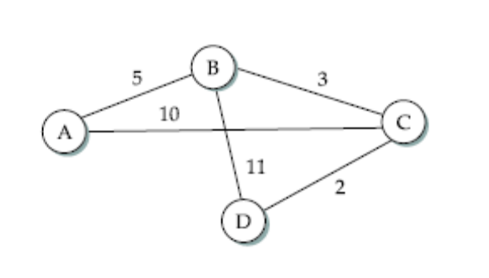
Fig: Link state routing, an example network

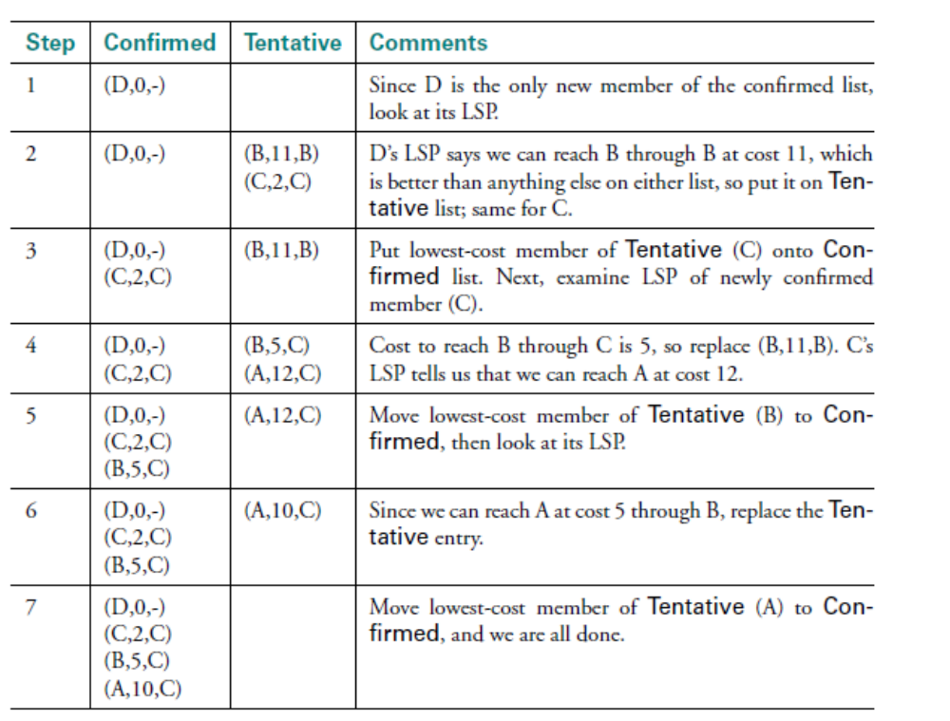
Table: Steps for building routing table for node D

METRICS
Here we discuss the ways to calculate the link costs. One example is to assign a cost of 1 to all links—the least-cost route will then be the one with the fewest hops. Such an approach has several drawbacks.
- It does not distinguish between links on a latency basis. Thus, a satellite link with 250-ms latency looks just as attractive to the routing protocol as a terrestrial link with 1-ms latency.
- It does not distinguish between routes on a capacity basis, making a 9.6-Kbps link look just as good as a 45-Mbps link.
- It does not distinguish between links based on their current load, making it impossible to route around overloaded links.
The ARPANET was the testing ground for a number of different approaches to link-cost calculation.
Evolution of the ARPANET routing metric
The original ARPANET routing metric measured the number of packets that were queued waiting to be transmitted on each link, meaning that a link with 10 packets queued waiting to be transmitted was assigned a larger cost weight than a link with 5 packets queued for transmission. Using queue length as a routing metric did not work well, however, since queue length is an artificial measure of load—it moves packets toward the shortest queue rather than toward the destination
A second version of the ARPANET routing algorithm, sometimes called the “new routing mechanism,” took both link bandwidth and latency into consideration and used delay, rather than just queue length, as a measure of load. Under light load, it worked reasonably well. Under heavy load, however, a congested link would start to advertise a very high cost. This caused all the traffic to move off that link, leaving it idle, so then it would advertise a low cost, thereby attracting back all the traffic, and so on.
A third routing metric compressed the dynamic range of the matric.

